Quantifying greenhouse gas fluxes from Yale Forests

The Yale Forests provide students and researchers land in which to test stewardship and management strategies. As climate changes and forest dynamics and resiliency are likewise changing, the role of sustainable forestry management in greenhouse gas mitigation efforts has become a central question in silviculture. Natural climate solutions are land management actions including conservation and restoration that increase carbon storage or avoid greenhouse gas emissions in carbon dense ecosystems like forests, grasslands, and wetlands (Griscom et al., 2017). These are cost-effective strategies that help ensure that climate warming does not exceed the Paris Climate Agreement goal of 2˚C, and also preserves the environmental and social benefits of associated ecosystem services. Among the challenges to this approach is the refinement of our estimates of the size, partitioning, and residence time of forest carbon pools to reduce the uncertainty in carbon offsets and mitigation.
In accounting for different carbon pools, we have undertaken extensive methane measurements at the Yale Forests. Biogenic methane emissions are on the rise as a result of climate warming, and the implications of this are important because the warming potential of methane is 86-times more warming at 20-year timescales than carbon dioxide, which is the timescale most relevant to managing our climate targets. In order to mitigate greenhouse gas emissions to limit mid-century overshoot of climate targets, understanding methane emissions is critical. At the same time, as portable analyzer technology improves, we continue to identify novel methane sources. In the Amazon floodplain, wetland trees stems have recently been identified as major conduits of wetland-produced methane to the atmosphere (Pangala et al., 2017).
Upland soils constitute a significant atmospheric methane sink (4-10%) (Kirschke et al., 2013), and it was thought that in upland forests, soils were the only component capable of significant methane exchange. Elevated methane concentrations in upland tree stems have been identified, but direct measurement has lagged (Covey et al., 2012). Soil gas exchange is straightforward to measure, and in the tropics, smooth-barked tree stems are also easier, but upland forest stem measurements are complicated by the rough bark common to temperate deciduous tree species. Researchers have determined a solution to sealing chambers over heavily furrowed barks like the Red oak, Eastern hemlock, or White pine, and that is Playdoh. Children’s Playdoh is moldable, reusable, and gas-tight. Chambers can be affixed temporarily to any tree, and gas exchange can be measured with precision and at high temporal resolution using the Ultraportable Methane Analyzer (Figure 1).
Yale researchers have established a plot within the Yale-Myers Forest where they had identified, measured, mapped, and tagged every tree within a footprint extending ~300 x 500 m². The goals of this study have been to leverage this detailed tree mapping project into a study characterizing methane emissions from trees and soils along a soil moisture gradient. We established soil measurement chambers and chose a subset of trees to measure, representative of the Oak-Pine assemblage. By measuring a subset of trees every month for a year, the methane fluxes will be scaled to every mapped tree in the forest plot. Soil fluxes can likewise be scaled, to develop an annual methane budget of the site partitioned by trees and soils.

Preliminary results show that tree stems in both wetland and upland settings are a source of methane emissions. Of the 8 tree species sampled, only Red maple, Yellow birch, and Black birch emitted methane. Within that group of 3 species, a subset of individuals consistently emitted methane from their stems: 7 of the 15 of the Red maples measured and 4 of the 12 of the Birch sampled. We measured Red maples and Birches under both wetland and upland soil moisture conditions and found that Red maple methane fluxes were highest in wet soils, while Birches were highest in an upland setting. We are building towards a full year of measurement from trees and soils, which will help us to model the seasonality of greenhouse gas exchange. Average monthly rates of methane fluxes across the soil moisture gradient show that during the summer tree stem methane fluxes are highest, but in dry soils they make up a small proportion relative to the soil sink (Figure 2).
There are many process-based questions that remain outstanding. Relatively little is known about the drivers of methane production and emission in upland trees, and more data are necessary to better constrain the magnitude of spatial and temporal variability of methane emissions. These are future directions for this study, to better understand why certain species and individuals within that species emit methane. Ultimately, studies across northeastern forests assessing methane emissions from tree stems will help us to better manage forests for carbon sequestration by identifying the age, species, and tree conditions (ie: dry rot) most likely to emit methane.
The work done at Yale Forests on methane quantification and scaling involved collaboration with multiple lab groups, undergraduate interns, graduate students and postdoctoral researchers. We have also used our land holdings to research management techniques in forested peat bogs in Maine. Wetlands account for 30% of biogenic methane emissions, and we authored an article in review recommending strategic management of these ecosystems, particularly restored and newly created wetlands to limit new methane emissions. We partnered with researchers in the Yale School of engineering and Applied Science to develop and test geoengineering solutions to mitigate methane emissions from peat bogs. We developed an annual record of soil emissions, identified hotspots of methane within the peat bog, and applied iron oxide solution to the peat to act as an alternative electron acceptor, impeding methanogenesis, or methane production by microbes. Early results suggest that methane emissions were reduced, but more research is needed to determine the longer-term effects of these treatments on emissions. These studies will provide fundamental knowledge important to our understanding of methane emissions in natural systems and some boundaries on the potential efficacy of methane mitigation to land managers.

References

Pangala, S.R, Enrich-Prast, A., Basso, L.S., Bittencourt Peixoto, R., Bastviken, D., Hornibrook, E.R.C., Gatti, L.V., Marotta, H., Silva Braucks Calazans, L., Monica Sakuragui, C., Rodrigues Bastos, W., Malm, O., Gloor, E., Bharat Miller, J., Gauci, V. (2017). Large emissions from floodplain trees close the Amazon methane budget. Nature, 552, 230-234. https://doi.org/10.1038/nature24639.
Covey, K.R., Wood, S.A., Warren II., R.J., Lee, X., Bradford, M.A. (2012). Elevated methane concentrations in trees of an upland forest. Geophysical Research Letters, 39(15). https://doi.org/10.1029/2012GL052361.

Griscom, B. W., Adams, J., Ellis, P. W., Houghton, R. A., Lomax, G., Miteva, D. A., Schlesinger, W. H., Shoch, D., Siikamäki, J. V., Smith, P., Woodbury, P., Zganjar, C., Blackman, A., Campari, J., Conant, R. T., Delgado, C., Elias, P., Gopalakrishna, T., Hamsik, M. R., ... Fargione, J. (2017). Natural climate solutions. Proceedings of the National Academy of Sciences of the United States of America, 114(44), 11645–11650. https://doi.org/10.1073/pnas.1710465114
Kirschke, S., Bousquet, P., Ciais, P., Saunois, M., Canadell, J. G., Dlugokencky, E. J., Bergamaschi, P., Bergmann, D., Blake, D. R., Bruhwiler, L., Cameron-Smith, P., Castaldi, S., Chevallier, F., Feng, L., Fraser, A., Heimann, M., Hodson, E. L., Houweling, S., Josse, B., ... Zeng, G. (2013). Three decades of global methane sources and sinks. Nature Geoscience, 6(10), 813–823. https://doi.org/10.1038/ngeo1955
Figures

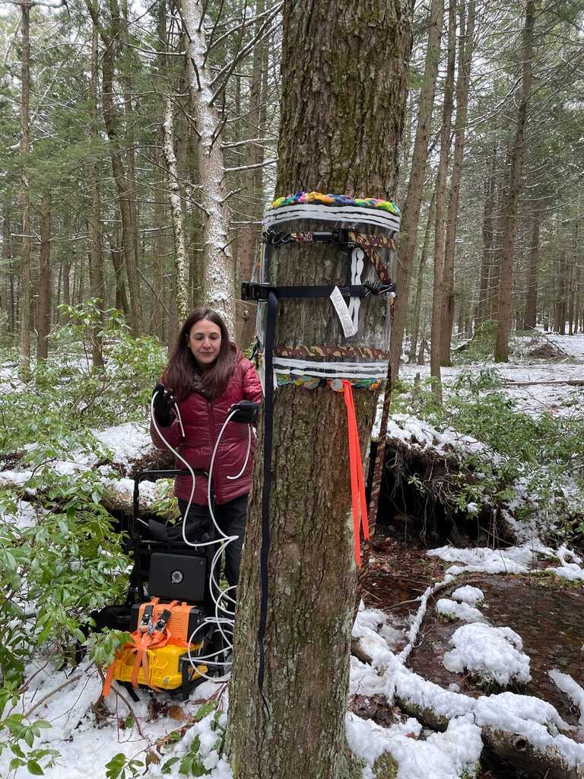
Figure 1. Attaching a chamber rimmed with Playdoh
to a Red maple tree at the Yale-Myers Forest, CT.

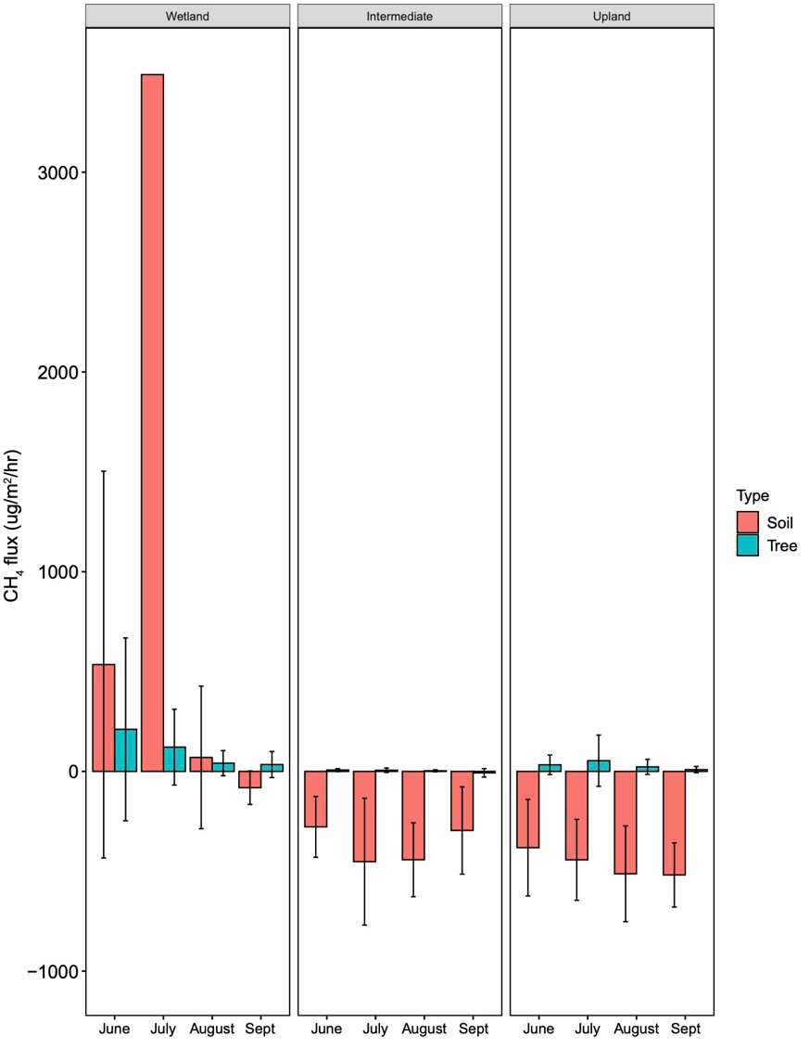
Figure 2. Mean monthly methane exchange with soils
(red) and trees (green) across wetland,
intermediate, and upland moisture conditions.

